**BIG DATA SAMSUNG PROJECT**

Docker running

Copying data to docker container

Access Postgres in the container

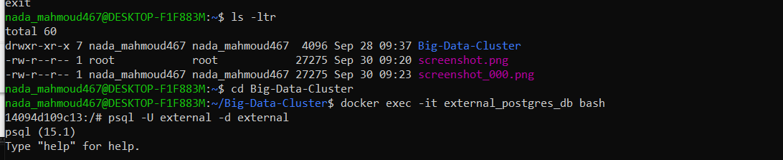

Create tables matching CSV schemas

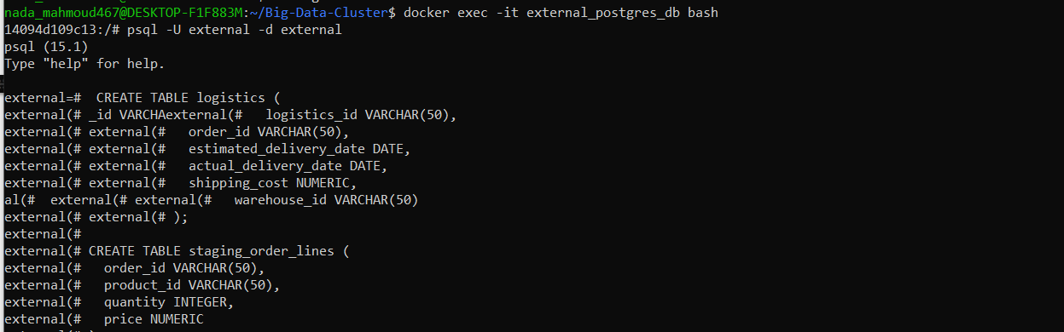

Load CSV files into Postgres tables



Show the data

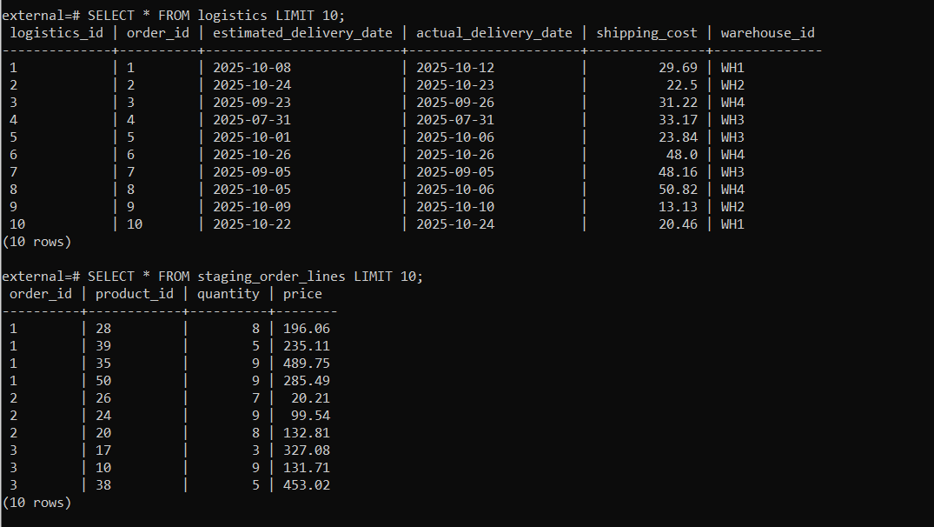

Extract data using Sqoop

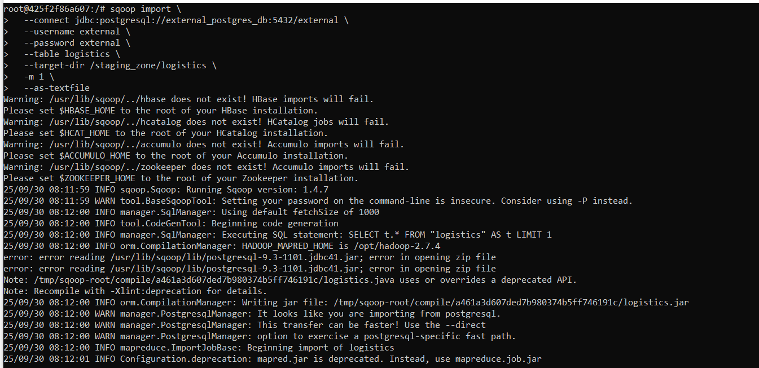

Extract 1000 record from logistics file

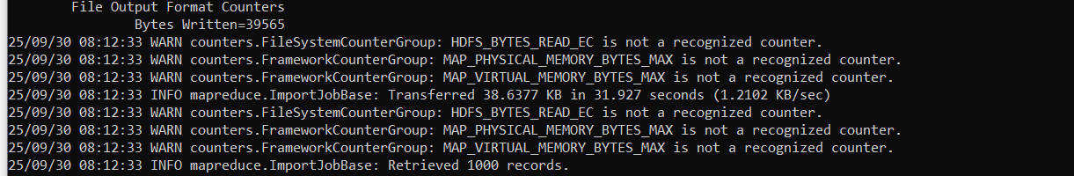

Extract data using Sqoop

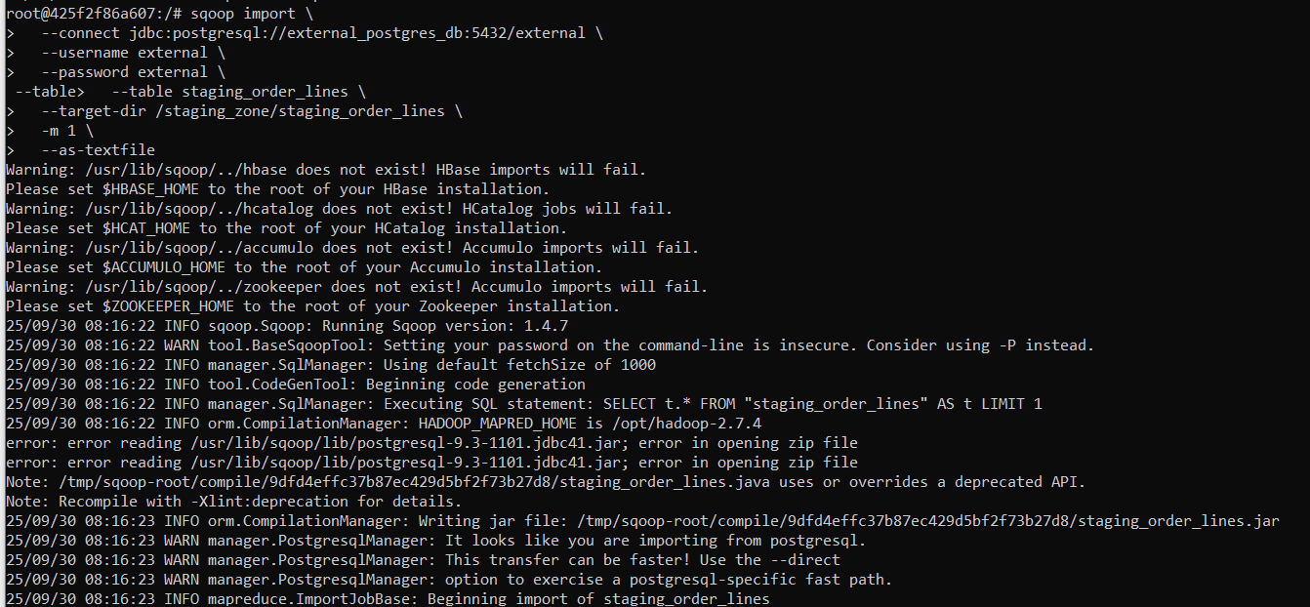

Extract 2970 record from staging _order_lines file

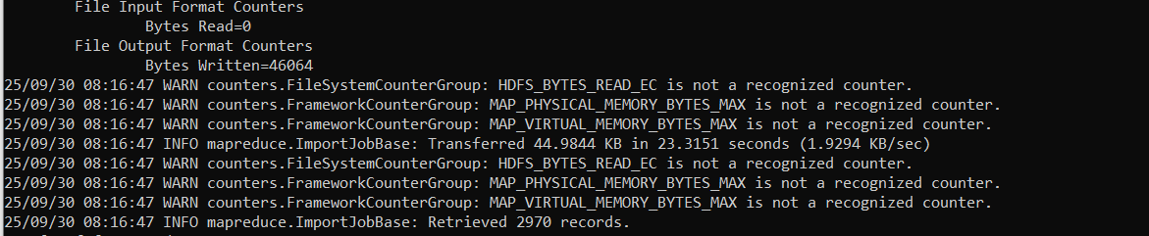

Transformation on zeppelin using Spark

1-Load data and assign column names

2-Inspect schema and sample data for logistics

3-Inspect schema and sample data for order lines

3-Clean and transform logistics data

4-Create logistics fact table

5-Join logistics fact with order lines to get revenue

6-Check if an order is served by multiple warehouses

7-Aggregate order-level summary

8-Aggregate warehouse-level summary

9-Calculate ratio of shipping cost to total revenue

10-Average delivery delay in days

11-Product-level analysis of late deliveries

12-Average delivery time delta (days) per warehouse

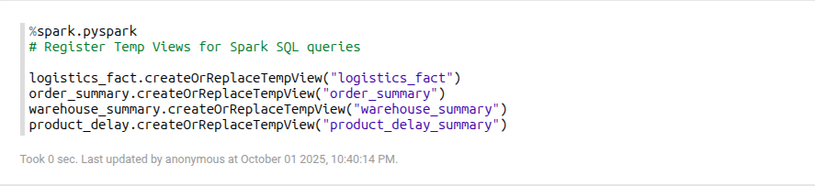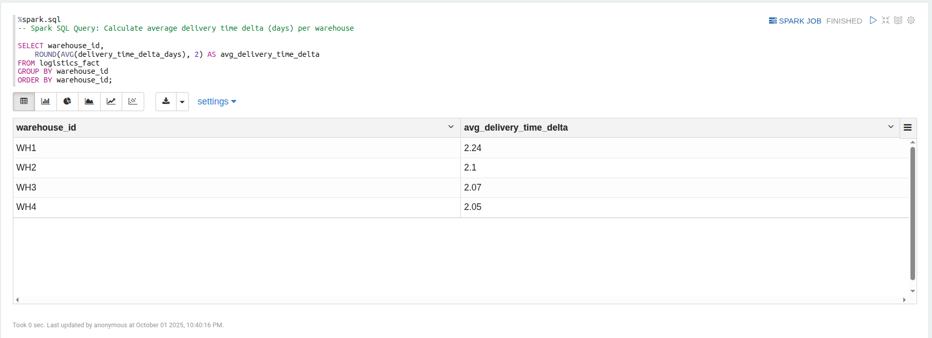

13-Top warehouses with highest late delivery rate

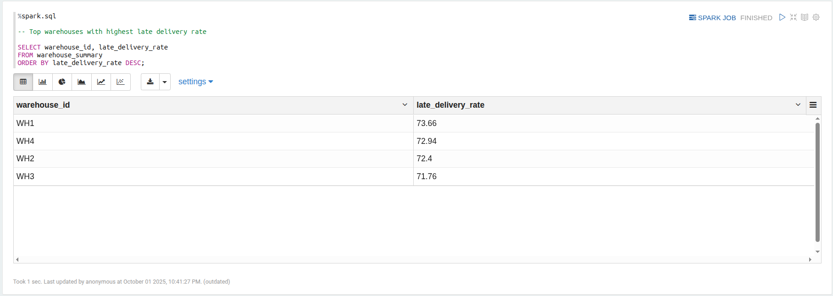

14-Top 10 products causing delay

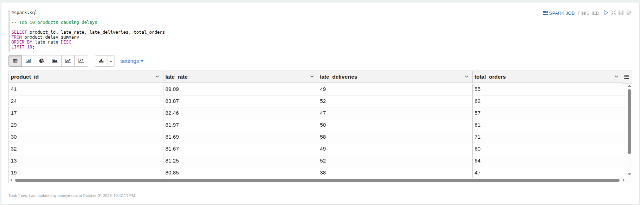

15- 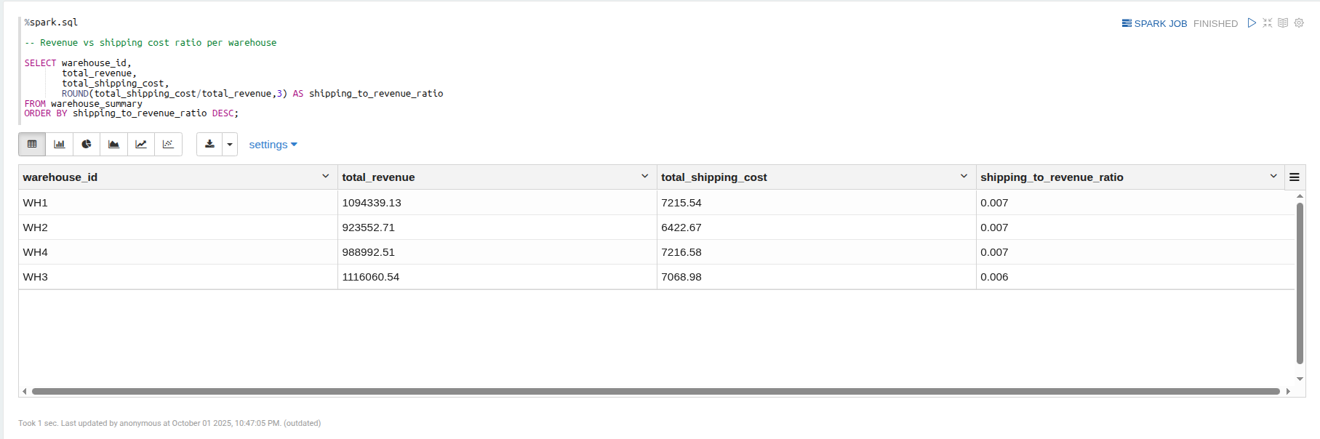Revenue vs Shipping cost ratio per warehouse

16- 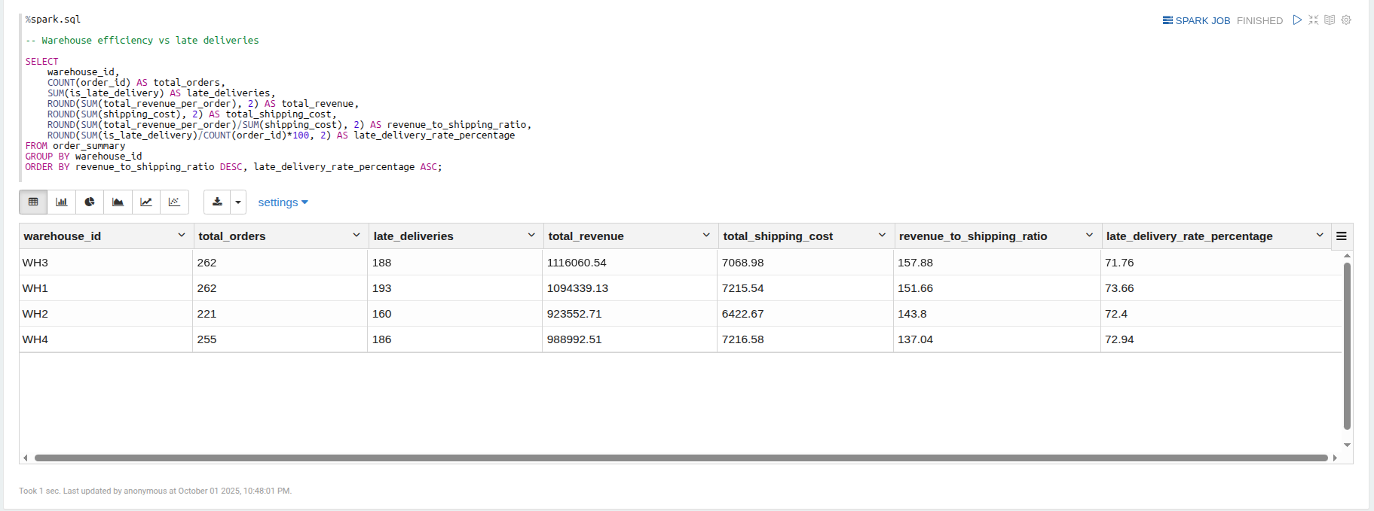Warehouse financial efficiency vs late deliveries

Star Schema for tables:

Fact_table (logistics_fact):

* order_id, delivery_time_delta_days, is_late_delivery, shipping_cost, warehouse_id

**order_summary:**

* **order_id, warehouse_id, is_late_delivery, shipping_cost, total_revenue_per_order**

**warehouse_summary:**

* **warehouse_id, total_revenue, total_shipping_cost, late_deliveries, total_orders, late_delivery_rate, avg_shipping_cost_per_order**

**product_delay:**

* **product_id, late_deliveries, total_orders, late_rate**